Ghana November 2021

Executive summary
This country fact sheet provides key trade, investment and tourism related statistics for Ghana. Specifically, it shows global trade and investment flows including an analysis of top markets and products for Ghana in relation to South Africa and the Western Cape, highlighting the largest and fastest growing products and sub-sectors. It also analyses tourism trends between the Ghana and South Africa. The key highlights are provided below:

Economy
The pandemic had a severe impact on economic activity in Ghana. Growth slowed to 0.4% in 2020 from 6.5% in 2019, food prices spiked, and poverty increased. Growth is expected to rebound to 4.7% in 2021, supported by a strong cocoa season and mining and services activity.

Trade
- Ghana’s trade balance seemingly followed a U-shape trend over the last 10 years, with a trade surplus of US$5.54bn recorded in 2011. Subsequently, this favourable trade balance deteriorated over the period to reach trade deficit of US$0.71bn by 2016, before recovering to reach a trade surplus of US$6.33bn by 2019.
- Export growth deteriorated by 26.40% in 2020, owing to the aftermath of the global lockdown initiatives implemented to combat the health crisis arising for the Covid-19 pandemic.
- Natural or cultured pearls dominated the export basket, accounting for 35.43% of exports at a value of US$4.34 billion in 2020, followed by mineral fuels (US$3.45 billion, or 26.37%) in second and cocoa and cocoa preparations (US$2.39bn or 19.4%) in third place.
- The export of meat or fish preparations had the highest growth in exports, increasing at an average annual rate of 12546.84% per annum from 2016 to 2020.
- China was Ghana’s largest export partner, with exports to China reaching US$2.81bn in 2019.
- Machinery and mechanical appliances were the largest imported good into Ghana in 2020, reaching a total import value of US$1.75bn (or 11%), with China being the top import partner for Ghanaian imports in 2019.

FDI
- A total of 431 FDI projects, representing a total capital expenditure of US$32.58 billion, were recorded into Ghana between January 2011 and September 2021.
- Over the same period, Ghana recorded 36 outward FDI projects and a total capital outflow of 319.59 million.
- As the second largest source market for inward FDI into Ghana, South African companies invested 47 FDI projects in the West African nation, 17% of which originated from the Western Cape.

Tourism
- The number of 5 257 Ghanaians visited to South Africa declined from 18381 in 2019 to 5 257 in 2020.
- There has been a consistent increase in the number of Ghanaian visitors arrival in the Western, from 3 505 in 2017 to 4 298 in 2020.

Table of Contents
1. General information 3
2. Economic overview 4
2.1 Ghana sovereign credit rating 5
3. Consumer insights 8
3.1 Household income expenditure 8
4. Trade 11
4.1 Ghana’s trade in goods 11
4.2 Western Cape’s trade with Ghana 14
4.3 Customs, regulations and standards 17
4.4 Port-to-port 18
5. Foreign Direct Investment 19
5.1 Inward FDI from the rest of the world to Ghana 19
5.2 Outward FDI from Ghana to the rest of the world 21
5.2 FDI flows between South Africa and Ghana 24
5.2.1 FDI flows from Ghana to South Africa 24
5.2.1 FDI flows from South Africa to Ghana 25
5.3 FDI flows between the Western Cape and Ghana 26
5.3.1 FDI from Ghana to the Western Cape 26
5.3.2 FDI from the Western Cape to Ghana 26
6. Tourism market overview: Ghana 28
6.1 Ghanaian tourist arrivals to South Africa 28
6.1 Ghanaian tourist arrivals into the Western Cape 28
6.2 Ghanaian passenger movement through Cape Town international airport 29

General information

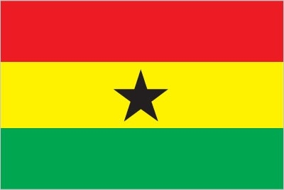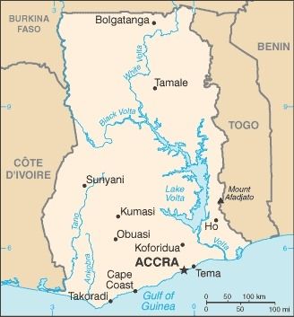

Formed from the merger of the British colony of the Gold Coast and the Togoland trust territory, Ghana in 1957 became the first Sub-Saharan country in colonial Africa to gain its independence. Ghana endured a series of coups before Lt. Jerry Rawlings took power in 1981 and banned political parties. After approving a new constitution and restoring multiparty politics in 1992, Rawlings won presidential elections in 1992 and 1996 but was constitutionally prevented from running for a third term in 2000. John Kufuor of the opposition New Patriotic Party (NPP) succeeded him and was re-elected in 2004. John Atta Mills of the National Democratic Congress won the 2008 presidential election and took over as head of state. Mills died in July 2012 and was constitutionally succeeded by his vice president, John Dramani Mahama, who subsequently won the December 2012 presidential election. In 2016, Nana Addo Dankwa Akufo-Addo of the NPP defeated Mahama, marking the third time that Ghana’s presidency has changed parties since the return to democracy.

Table 1: General information
Capital city | Accra
Government type | Presidential Republic
Chief of State | President Nana Addo Dankwa Akufo-Addo
Population | 32, 372, 889 (July 2021 est.)
Life expectancy | 69.01 years
Literacy | 76.6%
Ethnic groups | Akan 47.5%, Mole-Dagbon 16.6%, Ewe 13.9%, Ga-Dangme 7.4%, Gurma 5.7%, Guan 3.7%, Grusi 2.5%, Mande 1.1%, other 1.4% (2010 est.)
Religions | Christian 71.2% (Pentecostal/Charismatic 28.3%, Protestant 18.4%, Catholic 13.1%, other 11.4%), Muslim 17.6%, traditional 5.2%, other 0.8%, none 5.2% (2010 est.)
Languages | Asante 16%, Ewe 14%, Fante 11.6%, Boron (Brong) 4.9%, Dagomba 4.4%, Dangme 4.2%, Dagarte (Dagaba) 3.9%, Kokomba 3.5%, Akyem 3.2%, Ga 3.1%, other 31.2% (2010 est.)
HDI (2020) | 0.611 (Ranked 138th)
Sources: CIA World Factbook (2021); Human Development Indicators (2021)

Economic overview
Ghana has a market-based economy with relatively few policy barriers to trade and investment in comparison with other countries in the region, and the country is endowed with natural resources. The economy was strengthened by a quarter century of relatively sound management, a competitive business environment, and sustained reductions in poverty levels, but in recent years has suffered the consequences of loose fiscal policy, high budget and current account deficits, and a depreciating currency.

The outbreak of the COVID-19 pandemic in 2020 hit the country. Growth slowed from 6.5% in 2019 to 0.4% in 2020, food prices spiked, and poverty increased. The economic outlook is improving, even though risks remain, including from the evolution of the pandemic and rising debt vulnerabilities. The fiscal deficit including energy and financial sector costs worsened to 15.2% of GDP, with a further 2.1% of GDP in additional spending financed through the accumulation of domestic arrears. Public debt rose to 79% of GDP. The current account deficit widened slightly to 3.1% of GDP as the decline in oil exports was partially offset by higher gold prices, resilient remittances, and weaker imports. The Ghanaian Cedi remained stable against the US dollar, partly due to central bank intervention, and gross international reserves remained at 3.2 months of imports. External and domestic financing conditions tightened considerably at the start of the pandemic, but have improved since, and Ghana successfully returned to international capital markets for a USD3bn Eurobond issuance in March 2021.

An economic recovery is underway. Growth is expected to rebound to 4.7% in 2021, supported by a strong cocoa season and mining and services activity, and inflation remaining within the Bank of Ghana target. The current account deficit is projected to improve to 2.2% of GDP, supported by a pickup in oil prices, and gross international reserves are expected to remain stable. The 2021 budget envisages a fiscal deficit of 13.9% of GDP in 2021, including energy and financial sector costs, and a gradual medium-term fiscal adjustment which would support a decline in public debt starting in 2024. However, this outlook is subject to significant uncertainty, including from new pandemic waves and risks associated with large financing needs and increasing public debt.

Table 2: Economic information
GDP, constant prices (national currency) (2021 est.) | GHS173.82bn
Real GDP growth (2021 est.) | 4.7%
GDP per capita, constant prices (2021 est.) | GHS5, 556.33
Inflation, consumer average prices (2021 est.) | 10.6%
BOG policy rate (27 September 2020) | 13.50%
Unemployment rate (2020) | 4.53%
Total Exports (2020) | USD12.34bn
Total Imports (2020) | USD15.79bn
Sources: IMF (2021); ECB (2021); Global Edge (2021); Trade Map (2021)

The pandemic had a severe impact on economic activity in Ghana. Growth slowed to 0.4% in 2020 from 6.5% in 2019, food prices spiked, and poverty increased. Growth is expected to rebound to 4.7% in 2021, supported by a strong cocoa season and mining and services activity.

Figure 1: Ghana real GDP and GDP growth rate, 2016 – 2026f
Source: IMF (2021)

The services sector remained the largest sector of the Ghanaian economy in the first quarter of 2020 with a share of 48.3 percent of GDP at basic prices. The GDP share of industry and agriculture were 31.6 percent and 20.1 percent respectively.
Figure 2: Contribution to gross value added: by industry, 2020
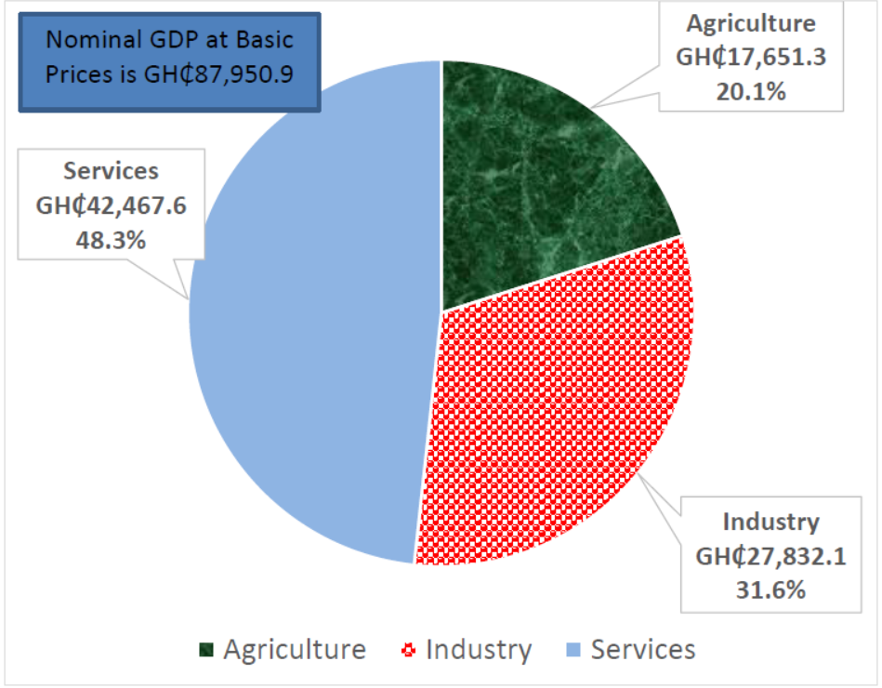
Source: Ghana Statistical Services, 2020

Ghana sovereign credit rating
“A sovereign credit rating is the credit rating of a country or sovereign entity. Sovereign credit ratings give investors insight into the level of risk associated with investing in a particular country and include political risks. At the request of the country, a credit rating agency will evaluate the country’s economic and political environment to determine a representative credit rating” (Investopedia, 2020).

While a number of credit agencies exist, the three most recognised credit ratings agencies globally are Fitch Ratings, Moody’s Investors Services (Moody’s) and Standard & Poor’s (S&P). Reasons for a country/sovereign to seek a credit rating from one of these three agencies include not only to access funding in international bond markets via the issuance of bonds in external debt markets, but it is a means to attract foreign direct investment. Obtaining a good sovereign credit rating instils confidence in investors seeking to invest in that country, with the credit rating a means for the country to demonstrate financial transparency and credit standing. Two key rating ‘standards’ exist, with the highest possible rating category being “AAA” according to S&P, which indicates that the rated country has extremely strong capacity to meet its financial commitments. A wide range of rating categories exists below this, with the categories ranging all the way down to SD (i.e., defaulted), which means the rated country has failed to pay one or more of its financial obligations when it came due.

Recently, on 3 September 2021, Moody's rated Ghana’s long-term issuer with a rating of B3 and the outlook remained negative. The B3 rating and negative outlook reflect Ghana's high debt burden that is unlikely to fall rapidly, continued weak debt affordability, high gross borrowing requirements and ongoing liquidity challenges in the face of downside economic, social and financial risks in the aftermath of the coronavirus pandemic. The rating affirmation also takes into account improving growth prospects, resilient external sector performance and Ghana's continued access to domestic and international capital markets, supported by the government's structural economic reform agenda to improve export competitiveness and broaden the revenue base.

On 12 September 2021, S&P gave Ghana a rating of B-. The agency considered Ghana's improving growth prospects, resilient external sector performance, and continued access to the capital markets [domestic and international] as essential factors in maintaining the rating and the outlook. Notably, the agency recognized the efforts of Government to “build back better” through the innovative Ghana CARES (Obaatanpa) Programme. However, concerns were raised about Ghana's debt affordability and levels. Citing that the COVID-19 pandemic will exacerbate Ghana's fiscal challenges, with government debt increasing to over 70% of GDP in 2020 and interest payments consuming half of fiscal revenue. Weaker tax revenue and slow economic activity are expected to widen the government's fiscal deficit to about 13.5%, which is one of the weakest levels among rated sovereigns in Africa, the rating agency said.

Earlier, on 21 June 2021, Fitch revised Ghana’s outlook to negative with a rating of B. The negative outlook reflected the significant deterioration in public finances stemming from the Covid-19 pandemic and the delays to the government's fiscal consolidation efforts, which reduce Ghana's ability to absorb further shocks for an extended period. The 'B' rating reflected the high public debt level and low revenue base, which mean that Ghana's debt affordability metrics will remain markedly weaker than rating peers over the rating horizon. This is balanced against Fitch's expectation of a recovery in economic performance and a stabilisation of debt/GDP and the ready availability of external and domestic financing. Ghana’s credit ratings from the major agencies are as following:

Figure 3: Ghana’ sovereign credit ratings, 2021
Credit rating agency | Standard & Poor | Moody’s Investor Services | Fitch Ratings
Credit rating | B- | B3 | B
Outlook | Negative | Negative | Negative
Date of last change | 2021-09-03 | 2021-09-03 | 2021-06-22
Sources: Fitch Ratings (2021); Moody’s Investor Centre (2021); Ministry of Finance, Ghana (2021)

A number of alternative measures and rating scales exist to assess risks posed to companies and banks, particularly those pertaining to political and commercial risks when undertaking international commercial transactions. One such company that offers these services is Belgium’s Delcredereducroire’s (the country’s official export credit agency and public credit insurer). The table below shows Delcredereducroire’s current risk assessment of Ghana in terms of export transactions and direct investments. Ratings are between 1 and 7, and between A and C, with 7 and C being the maximum risk indicators.
- In terms of political risks associated with exports transactions in Ghana, these are deemed to be relatively high both in the short term and medium to long-term.
- Business environment risk in turn also somewhat high.
- Regarding direct investments, all the categories are considered to be low risk except for currency inconvertibility as indicated by scores awarded below.
Table 3: Ghana’s risk assessment - Delcredereducroire
Export transactions (Scale 1 – 7)*
Political Risks | Short Term | 4
 | Medium-Long term | 5
 | Premium Classification OECD | 6
Business Environment Risk | E **
Direct investments
Political Violence Risk | 2
Risk of expropriation and government action | 3
Currency Inconvertibility and Transfer | 5
* Where 1 is associated with the least risk and 7 the most.
** Where B is associated with mid risk; A is low risk and G is high risk.
Source: ONDD (2021)

Consumer insights

Household income expenditure
The figure below presents Ghana’s consumer expenditure and growth for the period 2016-2020. In 2020, Ghana’s consumer expenditure stood at GHS292.02bn, an increase of 8.83% from the 2019 value of GHS268.34bn.

Figure 4: Consumer expenditure: Ghana, 2016-2020
Source: Euromonitor International (2021) [values at current prices*]

Note: Consumer expenditure comprises personal expenditure on goods - durable, semi-durable and non-durable - and on services in the domestic market, including the imputed rent of owner-occupied dwellings, the administrative costs of general insurance and of life assurance and superannuation schemes. Consumption expenditure in the domestic market is equal to consumer expenditure by resident households plus direct purchases in the domestic market by non-resident households and minus direct purchases abroad by resident households.

Ghana consumer expenditure per category in 2020 is presented in the figure below. The food and non-alcoholic beverages category was the largest consumer expenditure item in 2020, accounting for 41.56% of consumer expenditure. This was followed by housing (16.86%) and education (12.44%).

Figure 5: Consumer expenditure per category: Ghana, 2020
Source: Euromonitor International (2021) [values at current prices*]

Consumer trends in Ghana
- Per capita gross income in Ghana is forecast to increase by 35.1% in real terms over 2021-2040
- Later-Lifers are projected to remain predominant in the top-income band by 2040, shaping luxury spending patterns in Ghana
- income inequality is estimated to increase over the long term and remain extremely high by global standards, as the pandemic exacerbated the issue further
- Social class E is set to be the fastest growing social class and remain the prevalent social class through to 2040
- The Greater Accra region is anticipated to remain the largest consumer market in Ghana by 2040, accounting for 27.9% of total consumer expenditure
- Food and non-alcoholic beverages is forecast to be the largest consumer spending category in 2040, while transport will record the fastest growth over 2021-2040
Prospects
Large-scale fiscal stimulus to aid economic recovery from the pandemic
- Per capita gross income in Ghana is projected to increase by one third in real terms over 2021-2040, remaining below the pre-pandemic levels of 2019.
- The pandemic has had a severe impact on economic activity, causing a rise in unemployment and poverty rates. As a response measure, the government has dedicated USD16.5 billion to Ghana's CARES Obaatanpa programme, aiming to provide fiscal stimulus to drive growth and economic transformation by implementing major interventions such as free water and electricity, as well as increased pay for front-line workers.
- As the older consumers in the country represent an expanding segment, Ghanaians aged 65+ are set to dominate among the top-income band (those with an annual gross income over USD250,001) illustrating that the global trend of the rising importance of silver consumers is followed in Ghana. This age group is expected to generate opportunities for businesses focusing on premium goods and healthcare services.
- Present-day millennials are set to earn the highest per capita income by 2040, shaping Ghana’s consumer spending patterns.
- In 2020, internet users represented only a half of the total Ghanaian population however is set to reach 95% by 2040, therefore the rising importance of tech-savvy millennials offers expansion opportunities for telecom operators, which plan to provide a considerable boost to the Ghanaian information and communications technology (ICT) sector.
Income inequality is set to increase, as the lockdown constrained access to education
- Although Ghana is classified as a middle-income country by the World Bank since 2018, social class E (the lowest income class) remained prevalent in the country in 2020 and is set to witness the highest rate of expansion over 2021-2040.
- At the same time, social class A, the highest income class, is projected to witness the second fastest growth rate across social classes through 2040. This indicates that Ghana’s extremely high-income inequality is anticipated to continuously grow over the 2021-2040 period.
- Nearly one third of Ghana’s population lived below the international poverty line of USD3.1 per day in 2020. This results from a rapidly expanding population, significant underinvestment in infrastructure, limited access to education, and regional disparities.
- The COVID-19 pandemic has hit disproportionately more disadvantaged groups in Ghana, further widening the gap between the social classes and increasing income inequality. A survey by UNICEF in 2021 has concluded that online teaching was not sufficient for children from the most vulnerable households in Ghana due to internet connectivity being mainly available only to urban, employed, and literate Ghanaian families.
Trade and mobility in Accra to be more efficient due to improvements in transport infrastructure
- The Greater Accra region, which includes the capital Accra, was the largest consumer market in 2020, accounting for over a quarter of the country’s total consumer spending and is expected to witness the fastest rate of expansion through to 2040.
- The rapid development of the region was mainly driven by growing inflows of foreign direct investment (FDI) and a well-developed maritime sector.
- Due to better employment opportunities and higher standards of living, many people decide to leave homes in rural areas and move to Greater Accra. However, rapid urbanisation in Ghana causes various challenges, including poor road safety records and insufficient transport infrastructure. To mitigate the issues, Accra's government is improving the city's road infrastructure.
- In 2020, food and non-alcoholic beverages was the largest spending category in Ghana and is set to account for the largest share of consumer expenditure by 2040.
- Discretionary spending power in Ghana is set to slightly expand over the long term, representing 37.8% of total consumer spending in 2040, compared to 40.9% in other regional countries. Increasing discretionary spending potential is induced by rising expenditure on transport, which is anticipated to grow at the fastest pace over 2021-2040 among all expenditure categories.
- Elevated expenditure on transport in Ghana is partly due to increasing fuel prices, resulting in rising vehicle operation costs. Even though Ghana’s Private Roads and Transport Union has increased road transport fares by 13% in 2021, a number of private transport companies have announced an even higher acceleration in prices.

Trade

4.1 Ghana’s trade in goods
Figure 6 below paints a picture of goods traded in Ghana over the last 10 years, from 2011 to 2020. Ghana maintained a trade deficit in goods traded for most of the period under review. Seemingly, following a U-shaped trend, Ghana recorded a trade surplus in goods traded of USD5.54 billion before subsequently deteriorating consistently to reach a trade deficit of USD0.71bn by 2016. Thereafter, the current account recovered and the trade surplus followed in an upward trajectory to reach a trade surplus of USD6.33 billion by 2019. However, Ghana was not spared from the woes felt around the world, as the Coviid-19 pandemic caused a worldwide shut down and economic downturn was the new reality. To this end, Ghana’s imports exceeded its exports, resulting in a trade deficit of USD3.45 billion in 2020. On the other hand, both import and export growth remained relatively low, albeit average annual growth in exports were vastly larger (22.89%) when compared to imports (9.9%).

Figure 6: Ghana’s global trade in goods, 2011 - 2020

Source: TradeMap (2021)

In terms of Ghana’s top traded products, natural or cultured pearls dominated the export basket, accounting for 35.43% of exports at a value of USD4.34 billion in 2020. Mineral fuels followed in second place at an export value of USD3.45 billion, accounting for 26.37% of exports in the same year. Cocoa and cocoa preparations (USD2.39bn or 19.4%), edible fruit and nuts (USD582.45m or 4.72%), and ores, slag and ash (USD348.55m or 2.82%) made up the rest of the top five exported goods from Ghana in 2020. The export of meat or fish preparations as detailed below had the highest growth in exports, increasing at an average annual rate of 12546.84% per annum from 2016 to 2020. Ores, slag and ash followed in second place with an average growth of 28.06%, while edible fruit and nuts exports followed in third with a growth rate of 20.79% per annum from 2016 to 2020.

Figure 7: Ghana’s top 10 exported goods, 2020
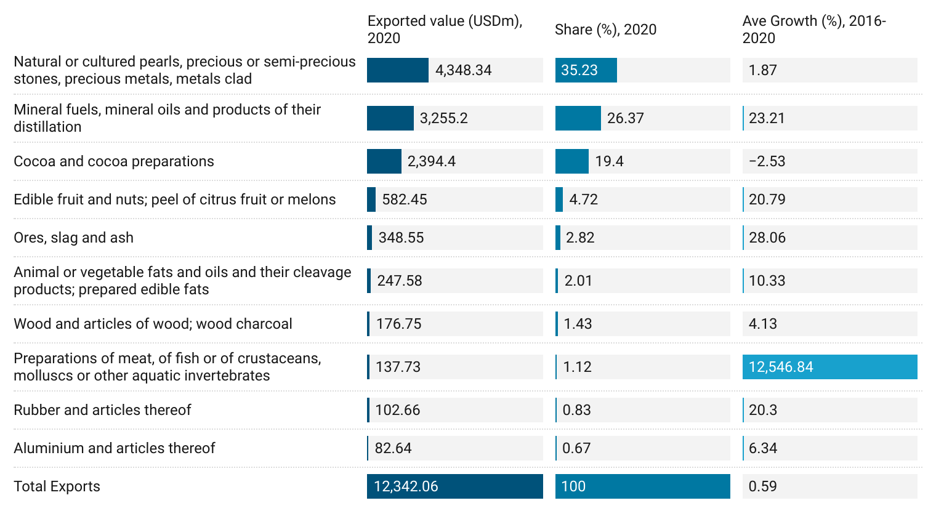
Source: TradeMap (2021)

Ghana is among the earliest countries to establish diplomatic relations with China and trade relations between the two countries remain strong. To this end, it is therefore no surprise that China was the Ghanaian country’s largest export partner, with exports to China reaching USD2.81 billion in 2019. Following in a close second place was Switzerland, where exports to the European powerhouse reached a close USD2.46 billion in 2019, while India ranked in a close third place with exports totalling USD2.38 billion in 2019. Moreover, exports to South Africa ranked in fourth place (USD971m), while the Netherlands (USD966.31m) and the United Arab Emirates (USD899.16m) completed the top five export markets for Ghana in 2019.

Figure 8: Ghana’s top export goods markets, 2019
Source: TradeMap (2021)

Turning to imports, machinery and mechanical appliances were the largest imported good into Ghana in 2020, reaching a total import value of USD1.75 billion and comprising a 11% share of the entire import basket. Vehicles and parts thereof ranked in second place with a value of USD1.37 billion (9%), while electrical machinery and equipment ranked in third with a value of USD1.18 billion in 2020 (holding a 7% share). Completing the top five largest imports into Ghana were the import of plastics and articles thereof (USD865.74m), while mineral fuel imports ranked in fifth place with a value of USD841.60 million and accounted for 5% of Ghana’s import basket in 2020. Meat and edible meat offal showed the strongest growth in imports, increasing at an average annual rate of 49% per annum from 2016 to 2020, while other high growth imports were textile articles (35%); mineral fuels (30%); and plastics at an average growth rate of 16% from 2016 to 2020.

Figure 9: Ghana’s top 10 imported goods, 2020
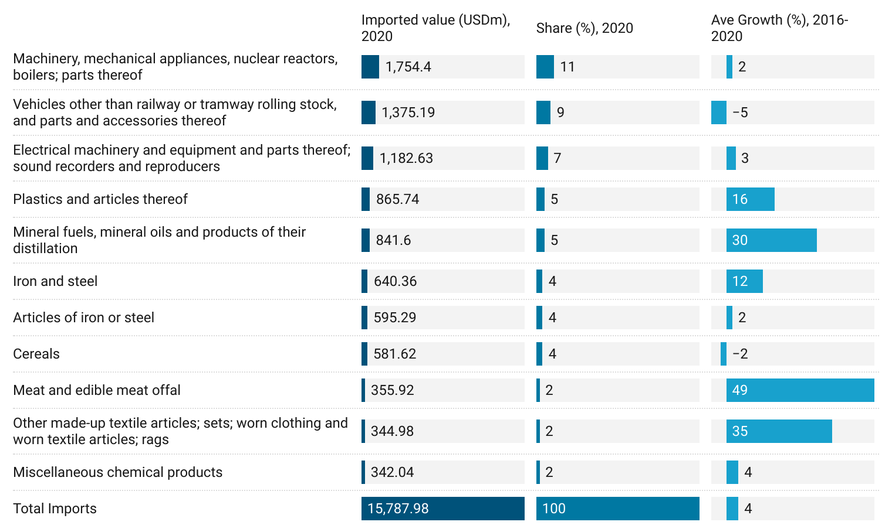
Source: TradeMap (2021)

Expectedly, with strong bilateral relations between China and Ghana, China ranked as the nation’s largest import partner in 2019, with imports reaching total value of USD1.89 billion in 2019. Imports from the United States, Ghana’s second largest import partner was half that of imports from China at USD976.22 million, while imports from the United Kingdom (USD685.55m), Belgium (USD532.89m) and Turkey (466.79m) ranked in third, fourth and fifth place, respectively in 2019. In contrast, South Africa was Ghana’s seventh largest import market, reaching a total import value of USD357.61m in 2019.

Figure 10: Ghana’s top import goods markets, 2019

Source: TradeMap (2021)
Figure 11 below illustrates Ghana’s dominance on the global trade front. In 2020, despite global disruptions to cross-border trade and disruptive supply chains, Ghana accounted for 0.1% of global exports and 0.1% of global imports, making it the 81st largest global exporter and the 82nd largest global importer in 2020. Furthermore, Ghana held a relative trade advantage in the exports of cocoa and cocoa preparations, given that it was the sixth largest global exporter of these traded goods in 2020. Moreover, Ghana was the ninth largest global importer of feather and downs, and the 33rd largest global importer of explosives and pyrotechnic products as shown in Figure 13 below:

Figure 11: Ghana’s competitive trade advantage, 2020

Source: TradeMap (2021)

Western Cape’s trade with Ghana
Turning to trade between the Western Cape and Ghana, the province has historically recorded a trade deficit for the most part, whereby associated import costs have traditionally outpaced export receipts earned by the Western Cape from associated trade with Ghana. This trend has relaxed between 2015 and 2016, where relatively smaller trade surpluses were recorded when compared to trade deficits seen. More specifically, large trade deficits were recorded in the 2013 (ZAR3.33bn) and 2014 (ZAR6.34bn) when compared to trade surplus in 2015 of ZAR776.4m. It is therefore not surprising that average annual growth in exports outstripped export growth, with imports growing at an average annual rate of 1324% when compared to the minuscule 18.08% growth in exports over the period 2011 to 2020.

Figure 12: Western Cape trade with Ghana, 2011 - 2020

Source: Quantec (2021)
The Western Cape’s dominant export product to Ghana in 2020 was that of fruit juices and vegetable juices at a value of ZAR105.65m. This was equivalent to 19.47% of all export receipts earned by the Western Cape from trade with Ghana in the year. Apples, pears and quinces placed second at a value of ZAR103.43m (19.06%), followed by ferrous waste and scrap at ZAR28.88m (5.32%). The Western Cape’s fastest growing export product categories over the six-year period leading up to and including 2020 were containers designed for carriage (458.09%), chlorides (192.02%) and refined petroleum oils (137.23%).

Figure 13: Western Cape top 10 exports to Ghana, 2020
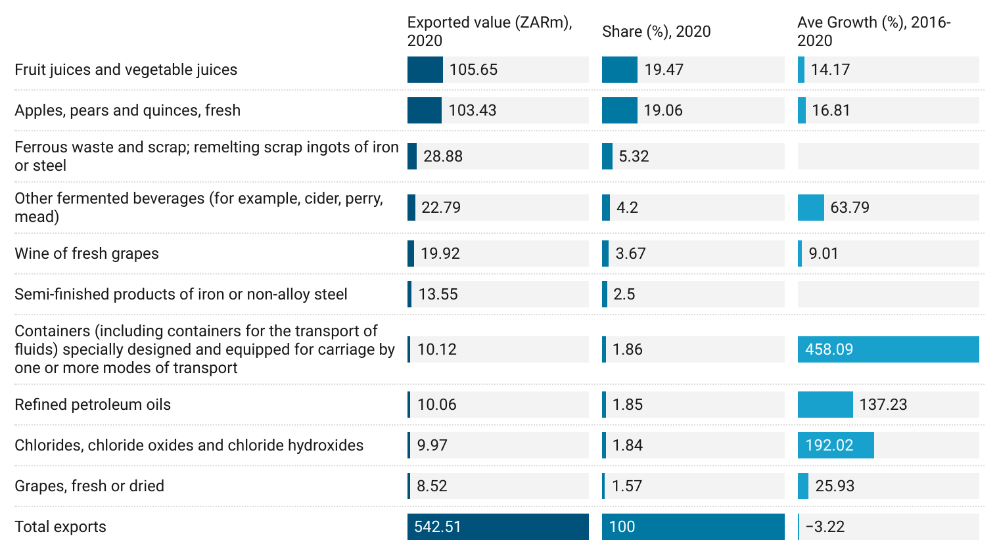
Source: Quantec (2021)

In contrast, crude oil significantly dominated products imported by the Western Cape from Ghana in 2020 at a cost of ZAR677.46m. This was equivalent to 98.55% of all import costs incurred by the Western Cape with Ghana in the same year. Other large but less significant imports from Ghana were wood sawn, which placed second at a cost of ZAR3.09m (0.45%), followed by other fixed vegetable fats and oils (ZAR1.36m or 0.2%).

Figure 14: Western Cape top 10 imports from Ghana, 2020
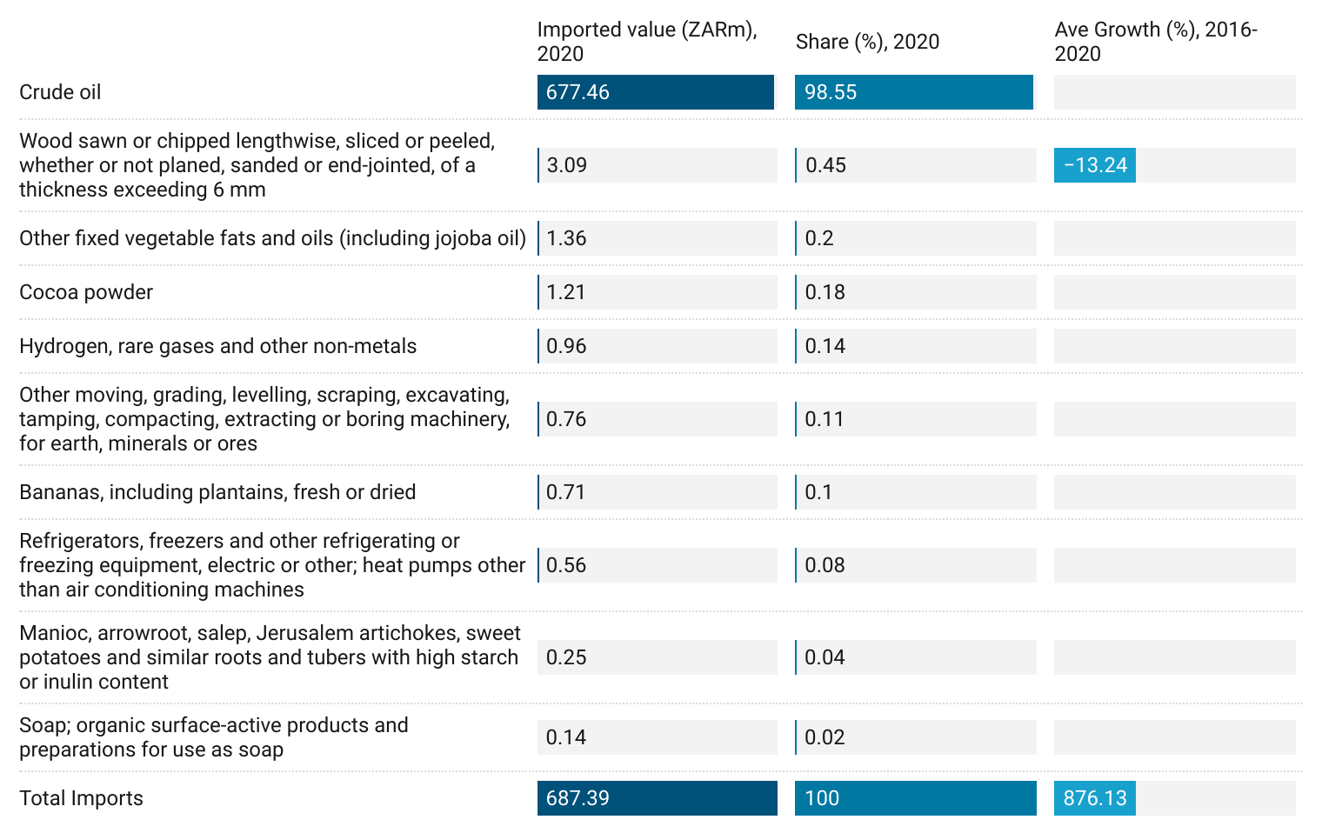
Source: Quantec (2021)

Trade between the Western Cape and Ghana is relatively well diversified. The two diagrams below are reflective of this and provide an overview of key trade flows between the Western Cape and Ghana on a sector level. As indicated in the graphs below, the food, beverages and tobacco sector were the Western Cape’s top sector in terms of export receipts earned from trade with Ghana in 2020, accounting for 34.58% of export earnings. This was closely followed by exports from the agriculture, forestry and fishing sector, which placed second and accounted for 22.83% of all Western Cape’s export receipts to Ghana, while the metals sector accounted for 12.21% in third position in 2020.

Figure 15: Top Western Cape export sectors to Ghana (% share), 2020
Source: Quantec (2021)

In contrast, the Western Cape’s top import sectors (ranked by associated cost) with Ghana last year revealed that the mining and quarrying sector dominated imports from Ghana, accounting for 98.55% of all import costs incurred in 2020. Other large but less significant importing sectors were the wood and paper industry (0.47%) in second place; food, beverage and tobacco sector (0.28%) in third, while the metals industry (0.21%) and the petroleum products industry (0.16%) ranked in fourth and fifth place in 2020.

Source: Quantec (2021)

Customs, regulations and standards

Import tariffs
- Ghana currently uses the Harmonized System (HS) Customs Code to classify goods.
- Taxes that are assessed based on weight, value or volume are subject to change annually. Goods arriving in the country may be subject to import duty, Value Added Tax (VAT), special tax and import excise duty.
- Duties are imposed on certain categories of exports also.
- Aside from a few items that are exempt from the payment of customs duty, all imports are subject to import duty plus VAT. VAT is calculated on the duty-inclusive value of the goods at rates contained in the HS manual. The extractive industries have sector specific exemptions and duties.

Labelling/marking requirements
Under Ghana’s General Labelling Rule, all products imported or produced locally should bear the following, in English:
- Name of product.
- Net mass or weight or net volume of content.
- Composition of content of product.
- Date of manufacture of product.
- Date of expiry of product (or best before date).
- Batch or lot number of products.
- Name and address of manufacturer or agent.
- Directions for use, if relevant.
- Any special instructions for storage, handling; etc. and
- Any pertinent warnings.

Prohibited and restricted imports
Some prohibited imports include narcotics, mercuric medicated soap, toxic waste, contaminated goods, certain tobacco products, certain agricultural materials and other goods prohibited by local law. Check a complete, current list of import restrictions.

Ghana trade agreements
Ghana is a member of the World Trade Organization (WTO) and a signatory to the ACP-EU Partnership Agreement, which replaced the Lomé Convention, a trade and aid agreement between the European Union and 46 of Europe’s former colonies and dependencies in Africa, the Caribbean and the Pacific (the ACP group). Ghana is also one of the beneficiaries of the U.S. African Growth and Opportunity Act (AGOA) quota and duty-free status and a key member of the Economic Community of West African States (ECOWAS).

Port-to-port

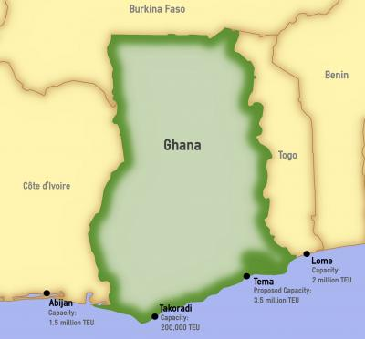
The Takoradi Harbour and Tema Harbour and ports serve Sekondi-Takoradi (Saltpond) and Tema's role as manufacturing centres and handles cargo in transhipment to and from bordering countries north of Ghana. The Golden Jubilee Terminal is a recently opened facility of the Tema port. The Fishing Harbour at Tema is a separate port facility. It is a commercial and industrial fishing port composed of four main areas, Inner Harbour, Outer Harbour, Canoe Basin and Commercial Area. The harbour handles the catch from commercial deep-sea fishing and canoe fishing.

Figure 16: Cape Town port terminal to main sea ports in Ghana
Ports | Distance | Transit time
Port of Saltpond | 4828.52 km | 8 days 8 hours
Port of Accra | 4824.24 km | 8 days 8 hours
Source: Sea-Rates, 2021.

Foreign Direct Investment
This section analyses inward and outward Foreign Direct Investment (FDI) flows to and from the Ghana between January 2011 and September 2021.

Inward FDI from the rest of the world to Ghana
Ghana is the 6th ranked destination market for inward FDI projects in Africa. Between January 2011 and September 2021, Ghana recorded a total number of 431 projects, which generated a total capital expenditure of US$32.58 billion and created about 73 083 jobs. The largest number of projects was announced in 2013, with 61 projects that year. Moreover, the largest capex and the highest number of jobs were recorded in 2017 and 2019 respectively.

Figure 17: Inward FDI into Ghana, Jan 2011-Sep 2021
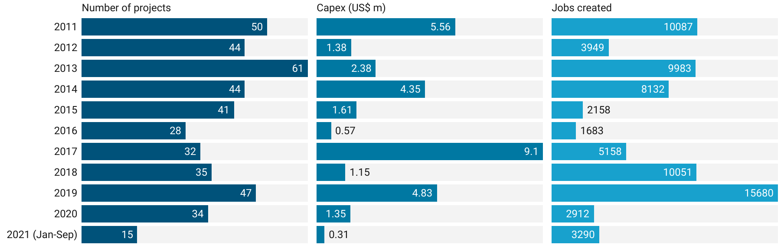
Source: FDI Intelligence (2021)

As can be seen from Figure 2, Western Europe account for the highest number of FDI projects as well as the largest capex into Ghana. During the period under review, 35% of inward FID projects and 52% of capex into Ghana were from Western Europe.

Figure 18: Inward FDI into Ghana: by world regions, Jan 2011-Sep 2021
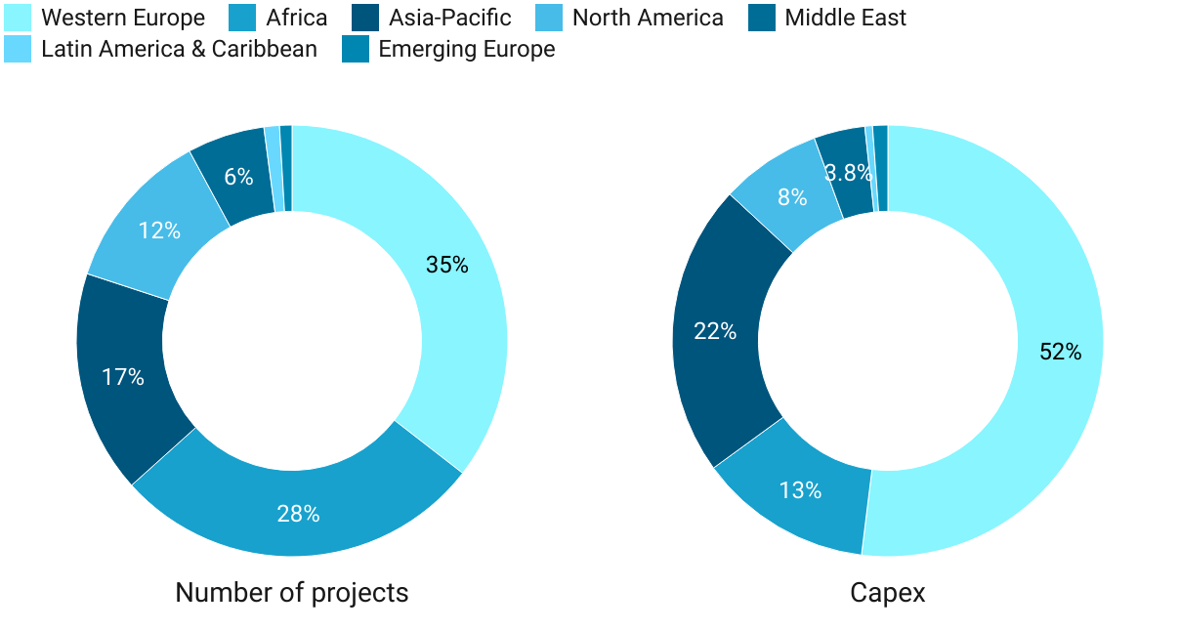
Source: FDI Intelligence (2021)

Figure 3 contains the top 10 countries with investment in Ghana in terms of both the number of FDI projects and the amount of capital expenditure from the first month of 2013 to the ninth month of 2021. Italy (24.9%) and Hong Kong (12.49%) were the top two countries with the largest amount of capex in Ghana, while the United States (11.14%) and South Africa (10.9%) had the highest number of FDI projects in Ghana.

Figure 19: Top 10 source markets for inward FDI into Ghana, Jan 2011-Sep 2020
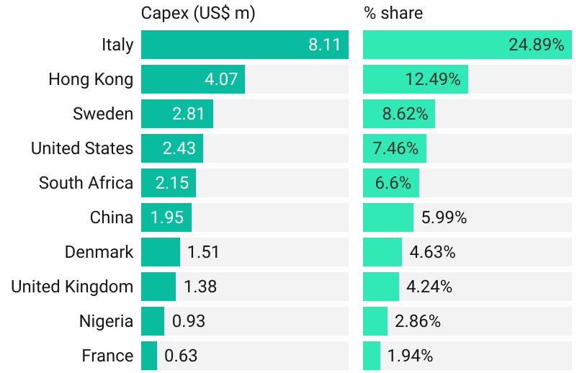
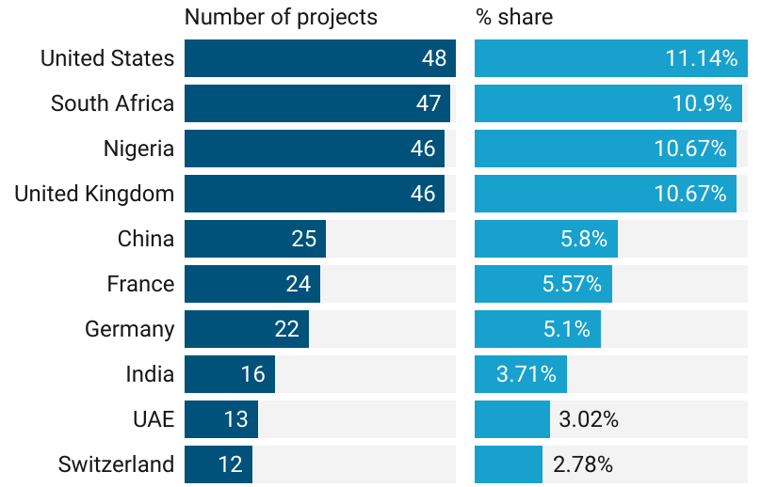
Source: FDI Intelligence (2021)

As shown in Figure 4, most of the capital inflows into Ghana were destined for the following industries: coal, oil and gas (US$10.22 b); metal (US$4.95 b); and paper, printing and packing (US$2.95 b). Similarly, financial services (80 projects), communications (50 projects) and business services (42 projects) recorded the highest number of inward FDI projects in Ghana between January 2011 and September 2021.

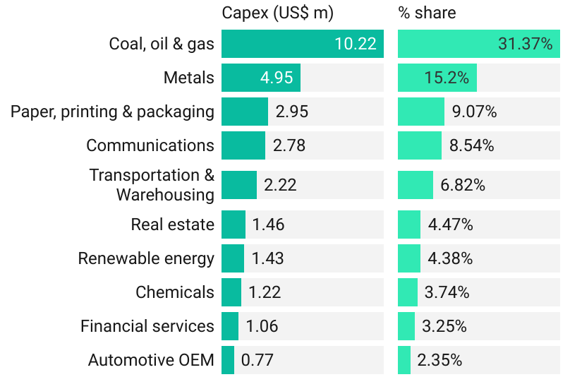
Figure 20: Ghana's inward FDI, top 10 sectors (Jan 2011-Sep 2020)
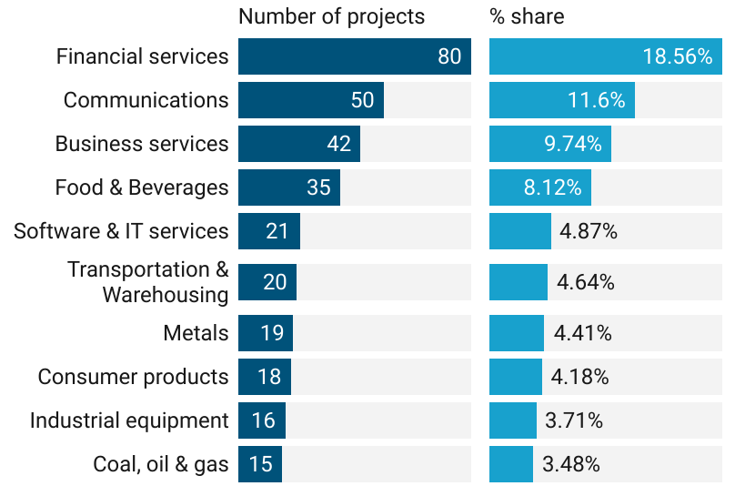
Source: FDI Intelligence (2021)

A total of 331 companies invested in Ghana between January 2011 and September 2021, out of a total 77,932 companies investing in FDI globally. The number of companies investing in Ghana peaked in 2013 as can be seen in Figure 5.

Figure 21: Number of companies by year and percentage of all companies, Jan 2011-Sep 2021

Source: FDI Intelligence (2021)
Table 1 shows the top 10 companies with the highest number of FDI projects in Ghana from January 2011 to September 2021. The top 10 companies accounted for approximately 15% of total projects. Access Bank tops the list with 10 projects, followed by MTN and Vodacom with 9 projects each.

Table 4: Top 10 companies investing in Ghana: number of projects, Jan 2011-Sep 2021
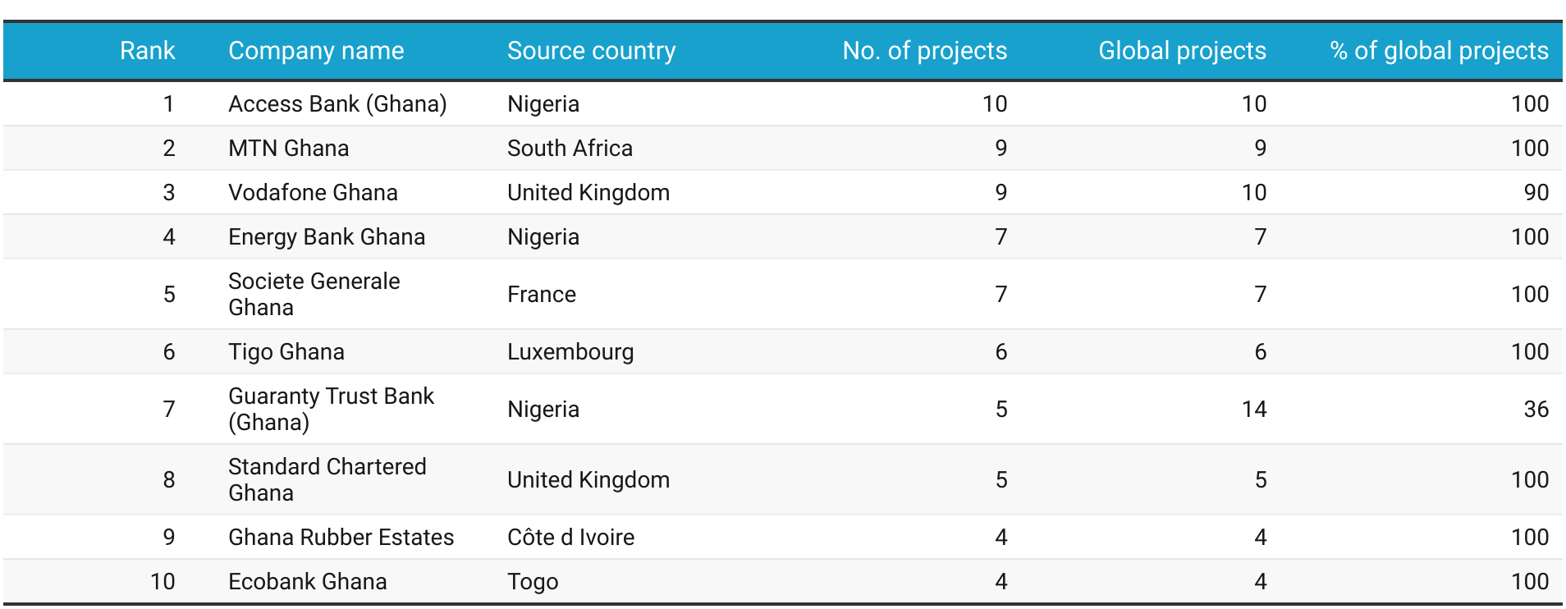
Source: FDI Intelligence (2021)

5.2 Outward FDI from Ghana to the rest of the world
Capital outflows from Ghana to the rest of the world totalled US$319.59 million during the period under consideration. These investments, which involved 36 projects, created about 1 945 jobs. The largest number of projects was announced in 2018, with seven projects that year. Average project size peaked in 2016 for both capital investment and jobs created.

Figure 22: Outward FDI from Ghana to the rest of the world, Jan 2011-Sep 2021
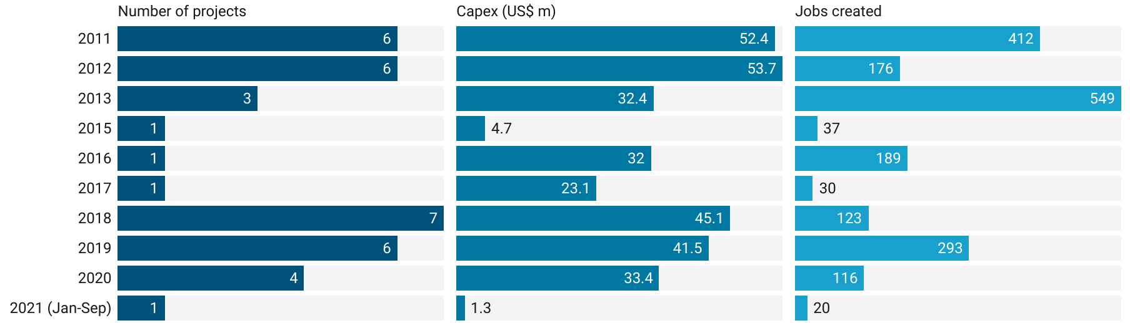
Source: FDI Intelligence (2021)

Africa was the largest destination region for outward FDI from Ghana as illustrated in Figure 7. The African continent accounted for 58% of projects and 72% of capex.
Figure 23: Outward FDI from Ghana: by world regions, Jan 2011-Sep 2021
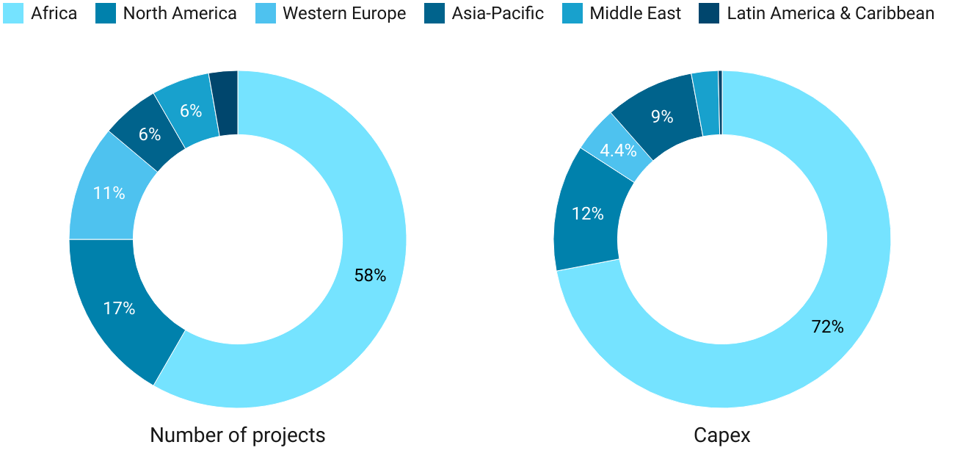
Source: FDI Intelligence (2021)

In terms of capex, outward FDI from Ghana was the largest in Nigeria (US$66.7 m), followed by Cote d’Ivoire (US$35.4 m) and South Africa (US$29.3 m) during the period under review. Seven of the top 10 countries that received the largest capex from Ghana are from the African continent. The top 3 countries that received the highest number of FDI projects from Ghana were Nigeria (13.89%), South Africa (11.11%) and the United States (11.11%).

Figure 24: Top 10 destination markets for outward FDI from Ghana, Jan 2011-Sep 2020
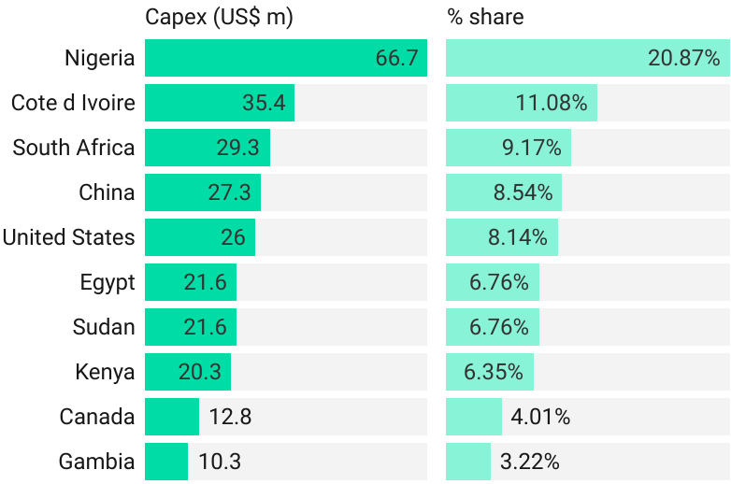
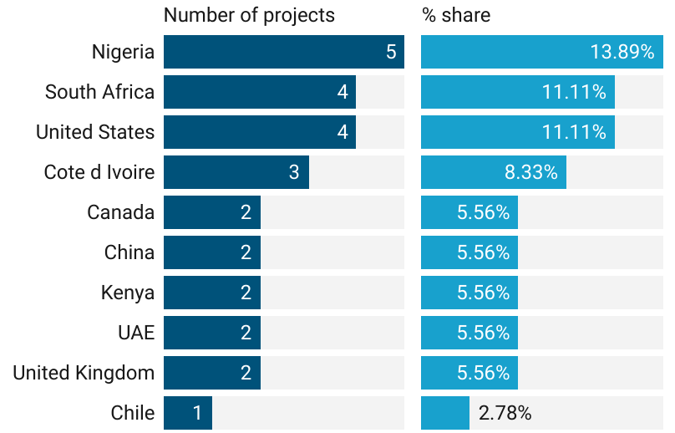Source: FDI Intelligence (2021)

About 22% of capex that emanated from Ghana to the rest of the world between January 2011 and September 2021 were made in the financial services industry, followed by communications (19.02%) and business services (17.83%). In terms of the number of outward FDI project, communications (19.44%) and financial services (19.44%) were the leading industries, followed by business services (13.89%).

Figure 25: Outward FDI from Ghana: by sectors, Jan 2011-Sep 2021
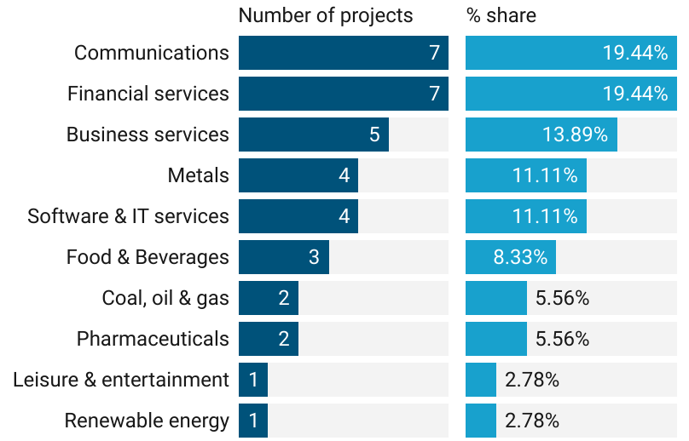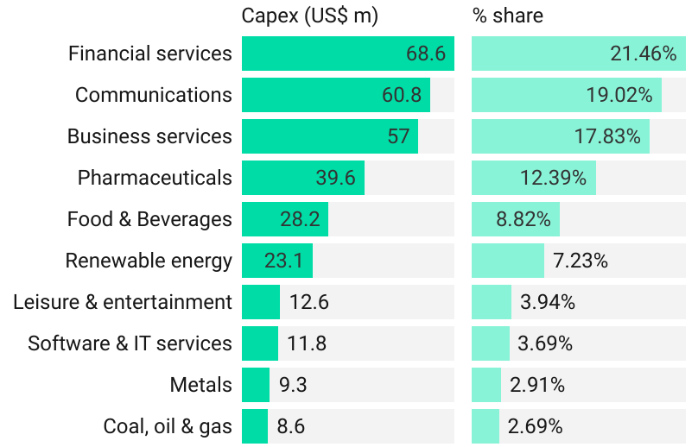
Source: FDI Intelligence (2021)

Out of a total 77,932 companies investing in FDI globally between January 2011 and September 2021, 20 were from. The number of companies from Ghana investing in FDI globally peaked in 2019 as shown in Figure 10.

Figure 26: Number of Ghanaian companies investing in the rest of the world, Jan 2011-Sep 2021

Source: FDI Intelligence (2021)

With 6 FDI projects, rLG Communications topped the list of the leading 10 companies from Ghana that invested in the rest of the world between January 2011 and September 2021. Menzgold (4 projects), ASFD (3 projects), GIHOC Distilleries (3 projects) and the Association of African Universities Corporation (3 project) completed the list of the top 5 Ghanaian companies with the highest number of FDI projects across the globe during the period under review.

Table 5: Top 10 companies: number of projects, Jan 2011-Sep 2021
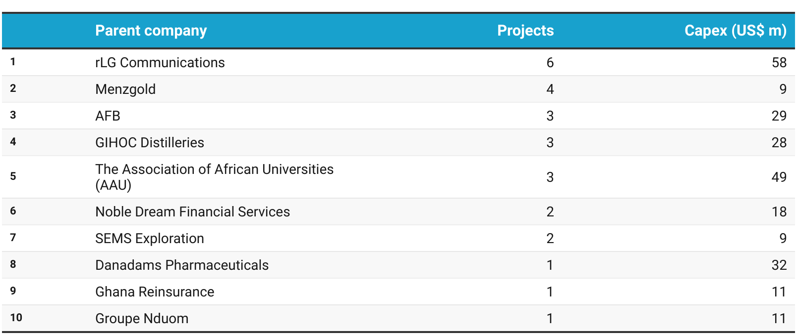
Source: FDI Intelligence (2021)

FDI flows between South Africa and Ghana
This sub-section focuses on FDI flows between Ghana and South Africa from January 2013 to September 2021.

FDI flows from Ghana to South Africa
Between January 2011 and September 2021, Ghana undertook a total of 4 FDI projects in South Africa. These projects generated an estimated capex of US$29.30 million, leading to the creation of about 64 jobs.

Figure 27: FDI from Ghana to South Africa, Jan 2011-Sep 2021
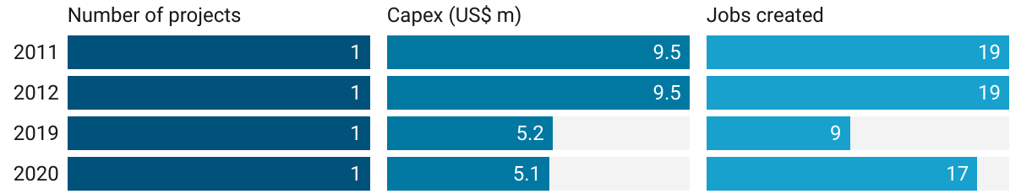
Source: FDI Intelligence (2021)

The South African industry that received the largest amount of capex from Ghana during the period under review was financial services (US$19 m), followed by software and IT services (US$5.2 m). Moreover, the South African industries that benefitted from FDI projects from Ghana were financial services (2 projects); food and beverages (1 project) and software and IT services (1 project).

Figure 28: FDI from Ghana to South Africa: by sector, Jan 2011-Sep 2021
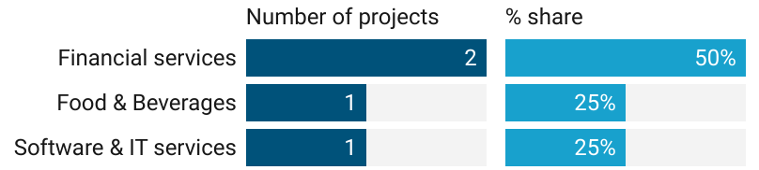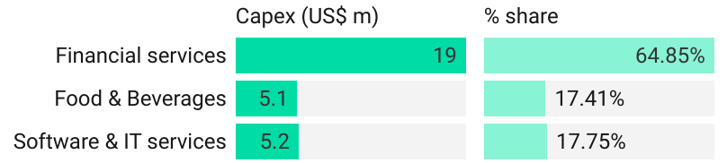
Source: FDI Intelligence (2021)

As shown in Table 3, the four Ghanaian companies that invested in South Africa between January 2011 and September 2021 were AFD, GIHOC Distilleries, Noble Dream Financial Services and OMG Digital.

Table 6: Companies from Ghana investing in South Africa, Jan 2011-Sep 2021
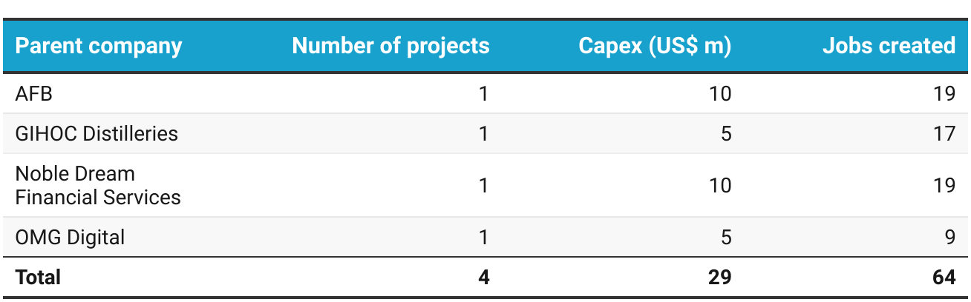
Source: FDI Intelligence (2021)

FDI flows from South Africa to Ghana
There was a total of 47 FDI projects by companies of South African origin in the Ghanaian market during the period under review. These projects were accompanied by a total capital expenditure of US$2.15 billion and the creation of 4 182 jobs.

Figure 29: FDI from South Africa to Ghana, Jan 2011-Sep 2021
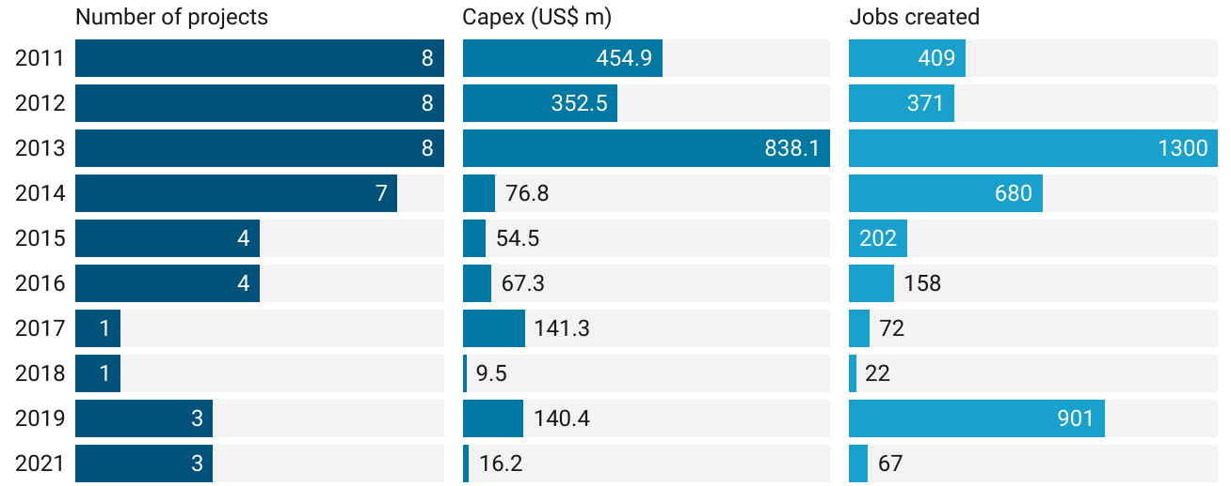
Source: FDI Intelligence (2021)

Approximately 41% of capex that originated from South Africa to Ghana was from the communications industry. Furthermore, communications and financial services were the top two industries in terms of the number of FDI projects.

Figure 30: FDI from South Africa to Ghana, Jan 2011-Sep 2021
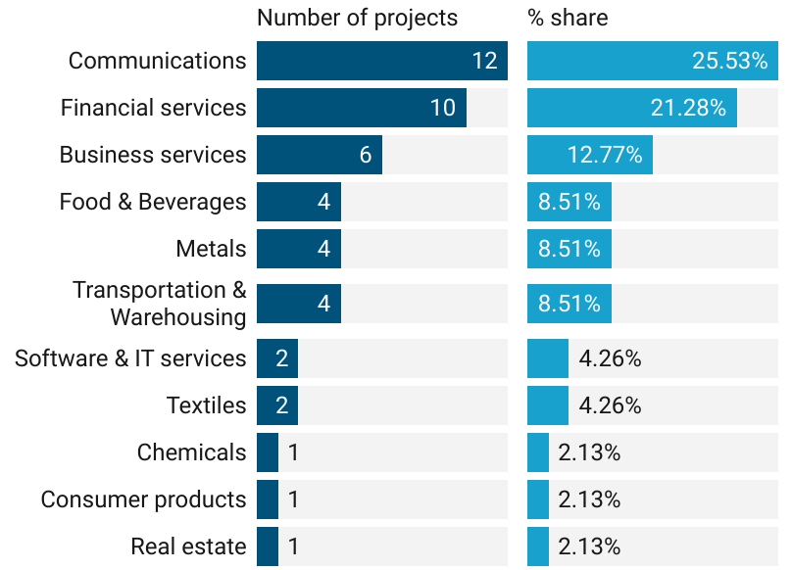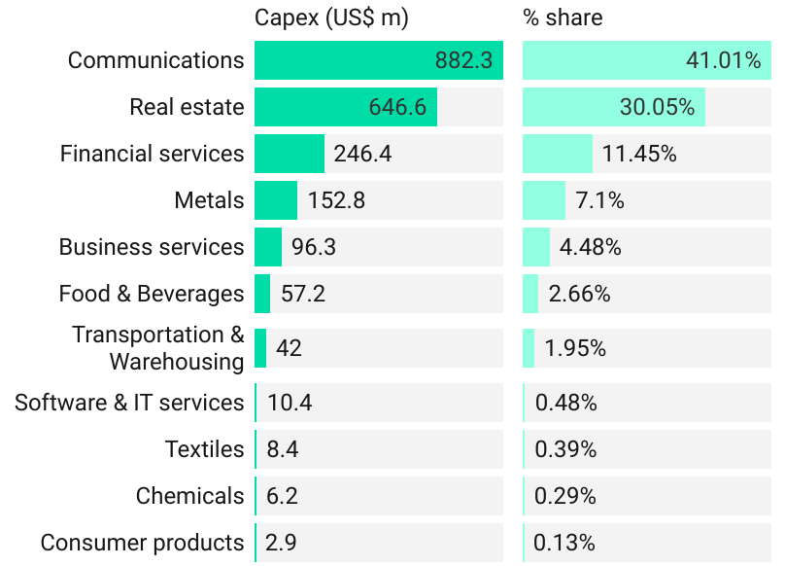
Source: FDI Intelligence (2021)
MTN Group, with 11 projects, was the South African company with the highest number of FDI projects in Ghana during the period under consideration, followed by FirstRand (6 projects) and Calulo Investment (2 projects).

Table 7: South African companies investing in Ghana: by projects, Jan 2011-Sep 2021
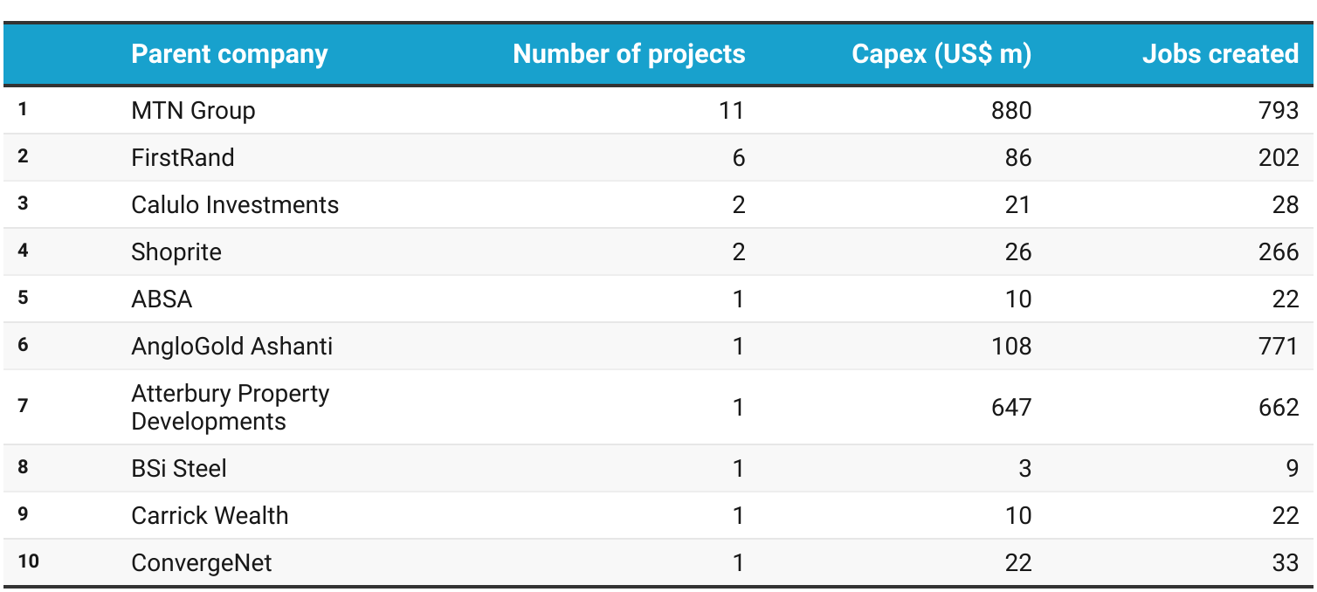
Source: FDI Intelligence (2021)

FDI flows between the Western Cape and Ghana
About 17% of South Africa’s outward FDI to Ghana, during the period under review, originated from the Western Cape.

FDI from Ghana to the Western Cape
Between January 2011 and September 2021, only 1 FDI project was recorded from Ghana to the Western Cape. This project, which was in the financial services industry, generated a capital inflow of US$10 million and created 19 jobs in the Western Cape.

Table 8: Companies from Ghana investing in the Western Cape, Jan 2011-Sep 2021
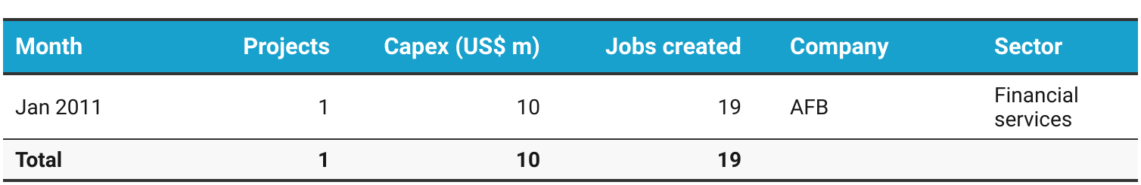
Source: FDI Intelligence (2021)

FDI from the Western Cape to Ghana
During the period under review, 8 FDI projects, with a total capex of US$96.40 million, were recorded from the Western Cape to Ghana. These projects created 917 jobs in total.

Figure 31: FDI from the Western Cape to Ghana, Jan 2011-Sep 2021
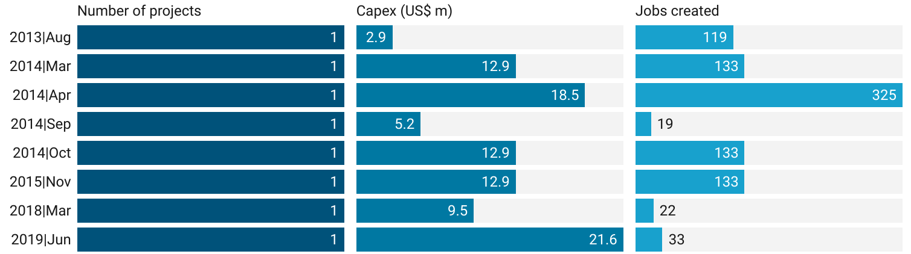
Source: FDI Intelligence (2021)

As evident in Figure 16, close to 60% of all capital outflows from the Western Cape to Ghana during the Jan 2011-Sep 2021 period were within the food and beverages industry. Moreover, food and beverages (with 50% of projects) was the highest ranked sector in terms of the number of FDI projects.

Figure 32: FDI from the Western Cape to Ghana: by sector, Jan 2011-Sep 2021
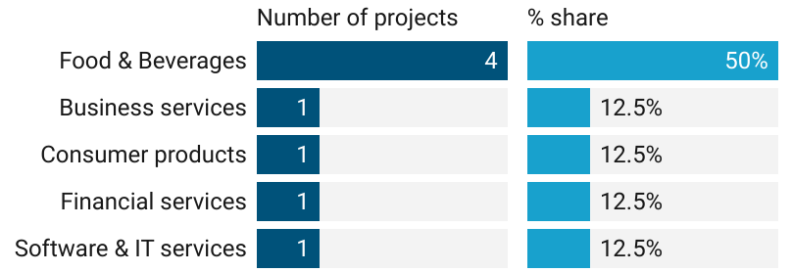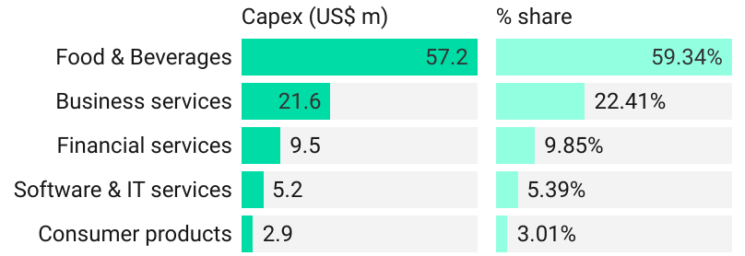
Source: FDI Intelligence (2021)

Shoprite, which was the top ranked company from the Western Cape with investment in Ghana, accounted for 2 of the 8 FDI projects as shown in Table 6. The company also recorded the largest capex during the period under review.

Table 9: Companies from the Western Cape investing in Ghana, Jan 2011-Sep 2021
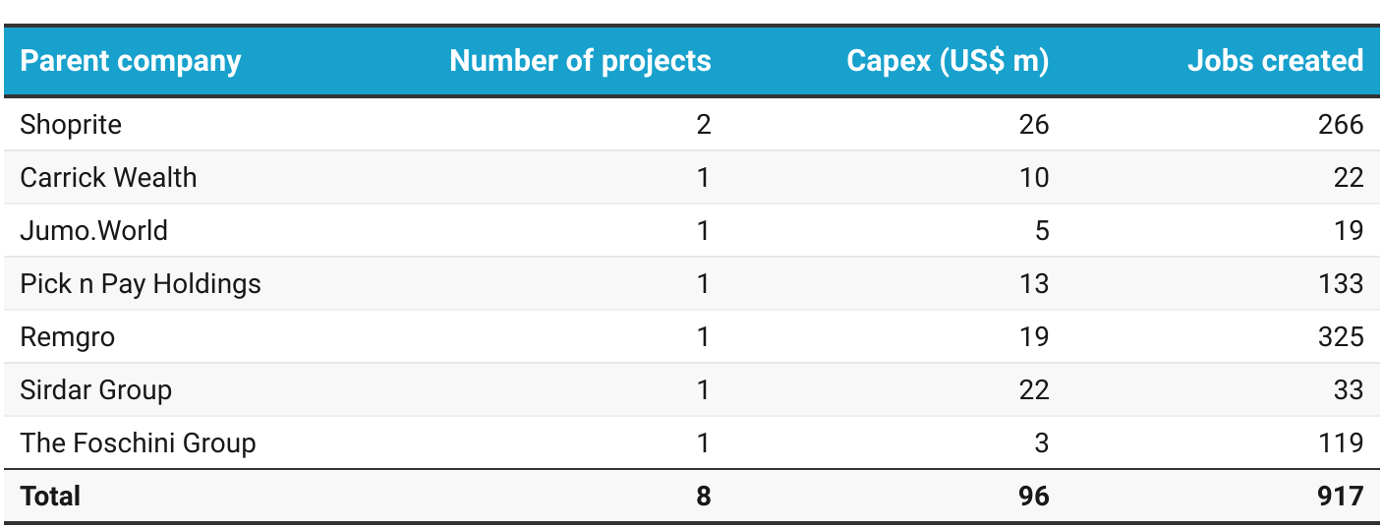
Source: FDI Intelligence (2021)

Tourism market overview: Ghana
Tourism is considered one of the world’s major economic sectors. It is the 3rd largest export category globally (after fuels and chemicals) and in 2019 accounted for 7 of global trade (UNWTO, 2020). In Africa, travel and tourism grew by 5.6% in 2018 compared to the global average of 3.9% with a growth of 3.2% for the economy. As such, Africa is considered the 2nd fastest growing tourism region in the world after Asia.

As the world is facing an unprecedented global health, social and economic emergency with the global COVID-19 pandemic, travel and tourism is among the most affected sectors, however with travel restrictions being eased, airplanes are no longer grounded, hotels have re-opened and travel restrictions put in place and virtually all countries around the world have changed.

Before the abrupt arrival of COVID-19 in 2020, tourism has been a driver for the South African economy over the last decade with consistent growth in tourism arrivals. The highest growth from this market being seen in 2018 with a 18.6% y-o-y growth and over 20,000 arrivals.

Ghanaian tourist arrivals to South Africa
The graph below depicts total tourist arrivals from Ghana into South Africa from 2017 - 2020. A -71.4% decline in Ghanaian tourist arrivals was experienced in 2020 due to the impact of the pandemic on international travel.

In 2020, Ghanaian tourist to South Africa primarily travelled for MICE (25.0%), Holiday (21.9%) and VFR (19.0%). Travellers from this country are typically youth, between the ages of 25-34 (36.8%) and 35-44 (29.5%).

Figure 33: Ghanaian tourist arrivals to South Africa, 2017-2020
Source: South African Tourism (SAT), 2021

Ghanaian tourist arrivals into the Western Cape
Over the past few years, the Western Cape saw the strongest volume in Ghanaian tourists in 2018 with (3 929) visitors, however 2019 saw a higher increase of 9.4% to reach 4 298 arrivals. Following Gauteng, the Western Cape consistently recorded the largest share of Ghanaian tourists between 2017 and 2019.
Source: South African Tourism (SAT), 2020
Figure 34: Ghanaian tourist arrivals to the Western Cape, 2017-2019

Ghanaian passenger movement through Cape Town international airport
According to the latest OAG Traffic Analyser data, Ghana passenger movement through the Cape Town International Airport started to plummet in April 2020. The decline followed after the nationwide lockdown commenced on 26 March 2020, resulting in no travellers for the period April – July 2020. Only 2 travellers were recorded in August and a mere 8 in September.

In spite of the severe decline in air-travel between the two countries recovery in passenger movement picked up in the remainder of 2020.

When observing movement over the first seven months of 2021, April and May recorded the largest number in Ghanaian passengers since the start of lockdown, with each month recording over 200 passengers.
Figure 35: Ghanaian passenger movement through Cape Town international airport, Jan 2019 - Jul 2021
Source: OAG Traffic Analyzer, 2021

DISCLAIMER:
Wesgro has taken every effort to ensure that the information in this publication is accurate. We provide said information without representation or warranty whatsoever, whether expressed or implied. It is the responsibility of users of this publication to satisfy themselves of the accuracy of information contained herein. Wesgro cannot be held responsible for the contents of the publication in any way.
© Wesgro, 2021

Sources: CIA World Factbook, 2021
Source: CIA World Factbook (2021); IMF (2021)
Sources: IMF (2021)
Source: Euromonitor International, 2021
Top export markets for Ghanaian goods traded from Trade Map was unavailable for the 2020 year at the time of writing. This paper will be updated as soon as this information becomes available.
Source: International Trade Administration (2021)

